**Pivot Table**

Pivot table in excel is used to categorize, sort, filter, and summarize any length of data table which we want to get count, sum, values either in tabular form or in the form of 2 column sets. To insert the pivot table, select the Pivot table option from the Insert menu tab, which will automatically find the table or range.

Create multitple pivot table with one click

First sort the data in descending order and create pivot table insert mode.

Than classify the categories in

🡪row

🡪column

🡪values

🡪fliter

In filter rather than typing manual click on top left side option

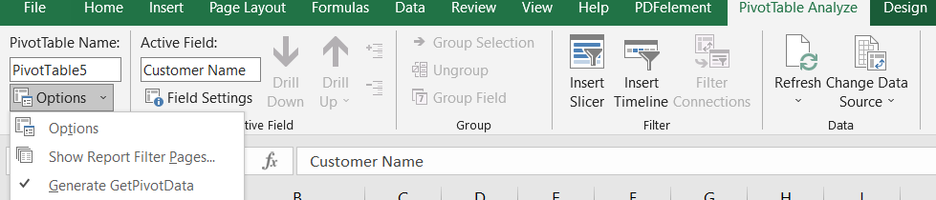

Select 2nd and click ok. This will create multiple tables with each filter in a new sheets.



**Bar graph of pivot table**

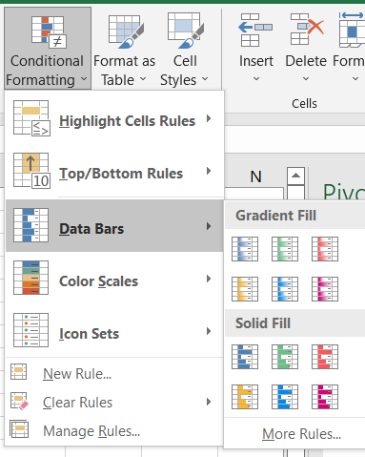 Click on home tab 🡪conditional formatting🡪data bars

**Calculated field**

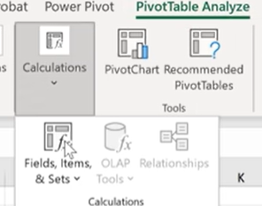

New field with some calculation from existing fields

U can delete ,modify your calculated fields.

Adding timeline in pivot table to check previous data entry .

Grouping helps the user to have a generalized and systematic way of expression data in groups. 